UNION WORKERS HAVE BETTER BENEFITS
Union workers are more likely than their nonunion counterparts to receive health care and pension benefits, according to the U.S. Department of Labor. In 1999, 73 percent of union workers in medium and large establishments had medical care benefits, compared with only 51 percent of nonunion workers. Union workers are also more likely to have retirement and short-term disability benefits.
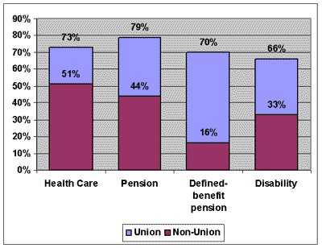
UNION WORKERS ARE MORE LIKELY TO HAVE
HEALTH AND PENSION BENEFITS, 1999
As the chart illustrates, 79% of union workers have pension plans versus 44 percent of nonunion workers. Seventy percent of union workers have defined-benefit retirement coverage, compared with 16 percent of nonunion workers. Defined-benefit plans are federally insured and provide a guaranteed monthly pension amount. They are better for workers than defined-contribution plans, in which the benefit amount depends on how well the underlying investments perform.

